EXP 1 : CHARACTERISTICS STUDY OF SIDE BAND POWER AND FREQUENCIES IN AM USING MATLAB
SOFTWARE USED : MATLAB SOFTWARE
CODE :
clc;
clear;
close all;

%% AM PARAMETERS
Am = 1; % Message amplitude (V)
Ac = 5; % Carrier amplitude (V)
fm = 500; % Message frequency (Hz)
fc = 5000; % Carrier frequency (Hz)
mu = 0.4; % Modulation index
Fs = 200000; % Sampling frequency (Hz)
t = 0:1/Fs:8e-3; % Time = 0 to 8 ms

%% 1. MESSAGE SIGNAL
m = Am*cos(2*pi*fm*t);

%% 2. CARRIER SIGNAL
c = Ac*cos(2*pi*fc*t);

%% 3. AM MODULATED SIGNAL
% Standard AM equation:
% s(t) = Ac[1 + mu*m(t)]cos(2*pi*fc*t)

s = Ac*(1 + mu*m).*cos(2*pi*fc*t);

%% 4. AM DEMODULATION
% Envelope detector using Hilbert transform
analytic_signal = hilbert(s);
envelope = abs(analytic_signal);

% Remove DC component and normalize
demod = (envelope - Ac)/(Ac*mu);

%% SIDEBAND FREQUENCIES
USB = fc + fm;
LSB = fc - fm;

%% POWER CALCULATIONS
% For AM:
% Carrier Power = Ac^2 / 2 (assuming R = 1 ohm)
% Each sideband power = mu^2 * Ac^2 / 8

R = 1; % Load resistance (ohm)

Pc = Ac^2/(2*R); % Carrier power
Pusb = mu^2*Ac^2/(8*R); % USB power
Plsb = mu^2*Ac^2/(8*R); % LSB power

Ptotal = Pc + Pusb + Plsb;

%% FREQUENCY SPECTRUM
N = length(s);

Y = fft(s);
P2 = abs(Y/N);
P1 = P2(1:N/2+1);
P1(2:end-1) = 2*P1(2:end-1);

f = Fs*(0:(N/2))/N;

%% FIND FREQUENCY COMPONENTS
% Exact theoretical frequencies
sideband_freq = [LSB fc USB];
sideband_mag = [Ac*mu/2 Ac/2 Ac*mu/2];

%% PLOT
figure('Color','w','Position',[100 100 1000 700]);

%% 1. MESSAGE SIGNAL
subplot(3,2,1);
plot(t*1000,m,'LineWidth',1.3);
grid on;
xlabel('Time (ms)');
ylabel('Amplitude');
title('1. Message Signal (Sine)');
xlim([0 8]);
ylim([-1.2 1.2]);

%% 2. CARRIER SIGNAL
subplot(3,2,2);
plot(t*1000,c,'LineWidth',1);
grid on;
xlabel('Time (ms)');
ylabel('Amplitude');
title('2. Carrier Signal (Sine Wave)');
xlim([0 8]);
ylim([-5.5 5.5]);

%% 3. AM MODULATED SIGNAL
subplot(3,2,3);
plot(t*1000,s,'LineWidth',1);
grid on;
xlabel('Time (ms)');
ylabel('Amplitude');
title('3. AM Modulated Signal');
xlim([0 8]);

%% 4. DEMODULATED SIGNAL
subplot(3,2,4);
plot(t*1000,demod,'LineWidth',1.3);
grid on;
xlabel('Time (ms)');
ylabel('Amplitude');
title('4. Demodulated Signal');
xlim([0 8]);
ylim([-1.2 1.2]);

%% 5. SIDEBAND FREQUENCIES
subplot(3,2,5);

stem(sideband_freq,sideband_mag,'filled','LineWidth',1.5);
grid on;
xlabel('Frequency (Hz)');
ylabel('Magnitude');
title('5. Sideband Frequencies (USB & LSB)');

xlim([4000 6000]);
ylim([0 3]);

% Label frequency components
text(LSB,sideband_mag(1)+0.1,...
sprintf('LSB = %d Hz',LSB),...
'HorizontalAlignment','center');

text(fc,sideband_mag(2)+0.1,...
sprintf('Carrier = %d Hz',fc),...
'HorizontalAlignment','center');

text(USB,sideband_mag(3)+0.1,...
sprintf('USB = %d Hz',USB),...
'HorizontalAlignment','center');

%% 6. SIDEBAND POWER
subplot(3,2,6);

power_values = [Pc Pusb Plsb];

bar(power_values);
grid on;

xlabel('Frequency Components');
ylabel('Power (W)');
title('6. Sideband Power');

set(gca,'XTick',1:3);
set(gca,'XTickLabel',{'Carrier','USB','LSB'});

ylim([0 max(power_values)*1.25]);

% Display power values
for k = 1:3
text(k,power_values(k)+0.2,...
sprintf('%.2f W',power_values(k)),...
'HorizontalAlignment','center');
end

%% DISPLAY RESULTS IN COMMAND WINDOW
fprintf('\n========================================\n');
fprintf(' AM CHARACTERISTICS\n');
fprintf('========================================\n');

fprintf('Message Frequency = %d Hz\n',fm);
fprintf('Carrier Frequency = %d Hz\n',fc);
fprintf('Modulation Index = %.2f\n',mu);
fprintf('Carrier Amplitude = %.2f V\n',Ac);

fprintf('\nSIDE-BAND FREQUENCIES\n');
fprintf('LSB Frequency = %d Hz\n',LSB);
fprintf('Carrier Frequency = %d Hz\n',fc);
fprintf('USB Frequency = %d Hz\n',USB);

fprintf('\nPOWER VALUES (R = 1 Ohm)\n');
fprintf('Carrier Power = %.2f W\n',Pc);
fprintf('USB Power = %.2f W\n',Pusb);
fprintf('LSB Power = %.2f W\n',Plsb);
fprintf('Total AM Power = %.2f W\n',Ptotal);

fprintf('========================================\n');
MODEL GRAPH :
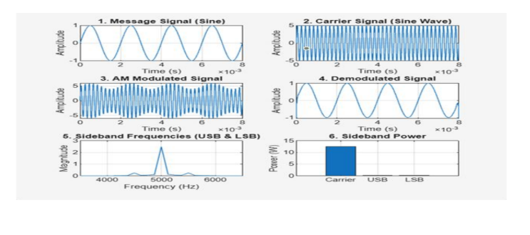
RESULT :
